**ADBMS assignment 1**

**Write and implement simple PL/SQL programs using declare, begin and end statements.**

1. **Write and Implement PL/SQL code to swap two numbers.**

**CODE:**

DECLARE

firstNumber number;

secondNumber number;

swap number;

number1 number;

number2 number;

BEGIN

firstNumber :=:number1;

secondNumber :=:number2;

swap := firstNumber;

firstNumber := secondNumber;

secondNumber := firstNumber;

DBMS_OUTPUT.PUT_LINE('first No. ' || firstNumber || ' Second No.' || secondNumber);

END;

**OUTPUT:**

first No. 5 Second No.5

Statement processed.

0.01 seconds

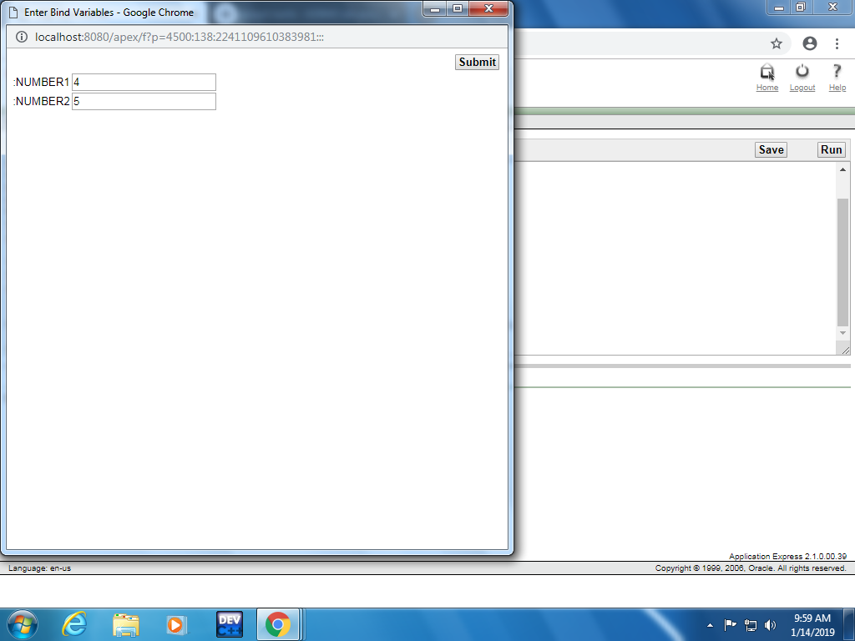

1. **Write and implement PL/SQL code to find student’s first name and last name from student table and print it on the screen.**

**Code:**

Declare

sid number;

fname varchar;

lname varchar;

Begin

sid:= :studentId;

select firstname,lastname from studentTab where =stuId = sid;

dbms_output.put_line('Student name:'||firstname||' '||lastname);

End;

1. **Write and implement PL/SQL code to calculate power of the number.**

DECLARE

firstNumber number;

secondNumber number;

number1 number;

number2 number;

BEGIN

firstNumber :=:number1;

secondNumber :=:number2;

secondNumber :=POWER(firstNumber, secondNumber);

DBMS_OUTPUT.PUT_LINE('Power of No. ' || secondNumber);

END;

**OUTPUT**

Power of No. 8

Statement processed.

0.00 seconds

1. **Write and implement PL/SQL code to determine day of week based on today's date.**

Declare

day varchar2(20);

Begin

day:=to_char(sysdate,'day');

Dbms_output.put_line('Today is :' || day);

End;

Result:

Today is :monday

Statement processed.

0.00 seconds

1. **Write and Implement PL/SQL code to print number 10 to 5 using simple loop, while loop and for loop.**

**Simple Loop**

DECLARE

counter number;

BEGIN

counter := 10;

Loop

DBMS_OUTPUT.PUT_LINE('counter = '|| counter);

counter := counter-1;

Exit when counter < 5;

END Loop;

END;

**Result:**

counter = 10

counter = 9

counter = 8

counter = 7

counter = 6

counter = 5

Statement processed.

**For Loop**

DECLARE

counter number;

BEGIN

counter := 10;

For counter in reverse 5..10 loop

DBMS_OUTPUT.PUT_LINE('counter = '|| counter);

END Loop;

END;

**result:**

counter = 10

counter = 9

counter = 8

counter = 7

counter = 6

counter = 5

Statement processed.

**While Loop**

DECLARE

counter number;

BEGIN

counter := 10;

While counter >= 5 loop

DBMS_OUTPUT.PUT_LINE('counter = '|| counter);

counter := counter-1;

END Loop;

END;

counter = 10

counter = 9

counter = 8

counter = 7

counter = 6

counter = 5

Statement processed.

1. **Write and Implement PL/SQL code to print the given number is even or odd.**

DECLARE

firstNumber number :=10;

result VARCHAR(10);

BEGIN

if mod(firstNumber,2) = 0 then

result := 'Even';

else

result := 'Odd';

END if;

DBMS_OUTPUT.PUT_LINE('Result : ' || result);

END;

**Result:**

Result : Even

Statement processed.

Result : Odd

Statement processed.

1. **Write and Implement PL/SQL code to find factorial of the number.**

Declare

fact number :=4;

n number := fact -1;

Begin

while n > 0 loop

fact:=n*fact;

n:=n-1;

End loop;

dbms_output.put_line(fact);

End

**Result:**

24

Statement processed.

0.00 seconds